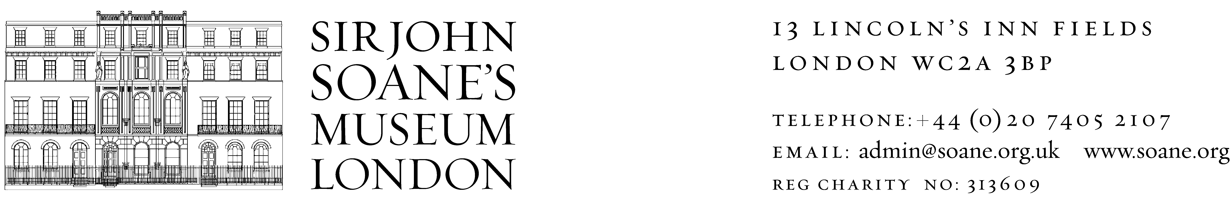

**Volunteer Visitor Assistant**

Volunteering alongside experienced members of staff you will play an integral role in the daily running of the Museum, through welcoming, engaging and inspiring our visitors, and helping to safeguard our collections.

The role includes full training, and suits anyone who enjoys our fantastic Museum and would like to support us through spending time here helping our visitors. Every Museum space at the Soane has a welcoming and helpful face, with Visitor Assistants based in several rooms, and volunteers based in the Dome, Crypt, Kitchen, or Flexible. Volunteers often spend time in the North Drawing Room or No.13 Breakfast Room

Our shifts run 10.00am to 1.30pm, and 1.30pm to 5.00pm, with x4 Volunteers for each, and Volunteers rotate around the spaces through the shift.

**Why volunteer at Sir John Soane’s Museum?**

* **Support** us as a charity.
* **Nurture your passion** for art, history, and architecture.
* **Enjoy** new experiences, **Learn** new skills, and **Develop** knowledge.
* **Meet new people** - from visitors to members of staff and fellow volunteers.

and everyone has a variety of interests and expertise!

* We reimburse **Travel Expenses**, up to a maximum of £12.50 a day.
* We organise a variety of **Volunteer Activities and Days Out** through the year.
* We give you an NMDC **Museum Pass** after completing 10 shifts!

**Who can be a Volunteer Visitor Assistant?**

We welcome applicants from all sections of the community. As an organisation we want to offer opportunities especially to those from our local community and to people new to museums and heritage. Through this role volunteers will develop skills in customer service and knowledge about museums and collections.

**Time commitment**

Our volunteers enable us to be free and open to the public, and for this we are incredibly grateful. We recommend volunteers offer one shift per week, but ask for at least one shift per month, or a minimum of 12 shifts total.

To apply please complete an application via our [Volunteer Portal](https://app.betterimpact.com/PublicOrganization/02e4739b-ad42-4ad0-88c6-fa87accb42dc/1), or alternatively please contact [volunteer@soane.org.uk](mailto:volunteer@soane.org.uk) for an application form.